**LOOP**

**1. Shell Script to display the first 10 natural numbers.**

**Expected Output :**

**1 2 3 4 5 6 7 8 9 10**

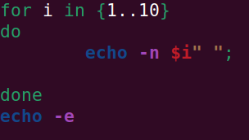

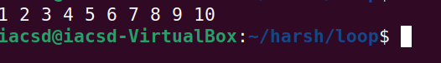

**2. Shell Script to compute the sum of the first 10 natural numbers.**

**Expected Output :**

**The first 10 natural number is :**

**1 2 3 4 5 6 7 8 9 10**

**The Sum is : 55**

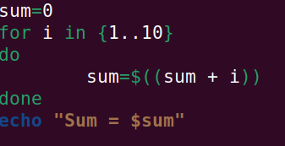



**3. Shell Script to display n terms of natural numbers and their sum.**

**Test Data : 7**

**Expected Output :**

**The first 7 natural number is :**

**1 2 3 4 5 6 7**

**The Sum of Natural Number upto 7 terms : 28**

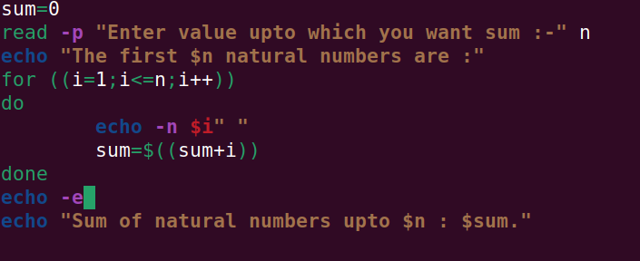

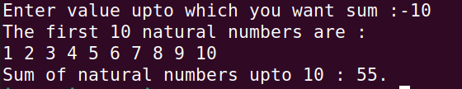

**4. Shell Script to read 10 numbers from the keyboard and find their sum and average.**

**Test Data :**

**Input the 10 numbers :**

**Number-1 :2**

**...**

**Number-10 :2**

**Expected Output :**

**The sum of 10 no is : 55**

**The Average is : 5.500000**

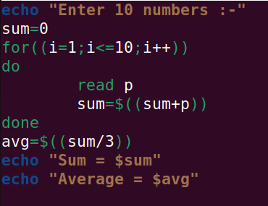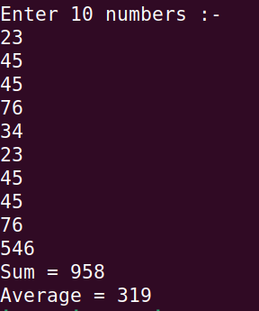

**5. Shell Script to display the cube of the number up to an integer.**

**Test Data :**

**Input number of terms : 5**

**Expected Output :**

**Number is : 1 and cube of the 1 is :1**

**Number is : 2 and cube of the 2 is :8**

**Number is : 3 and cube of the 3 is :27**

**Number is : 4 and cube of the 4 is :64**

**Number is : 5 and cube of the 5 is :125**

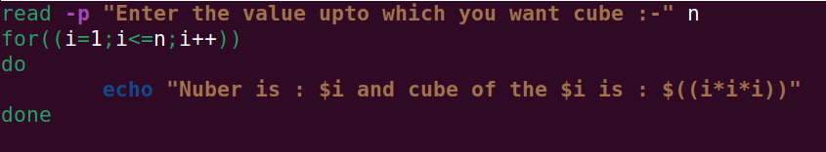

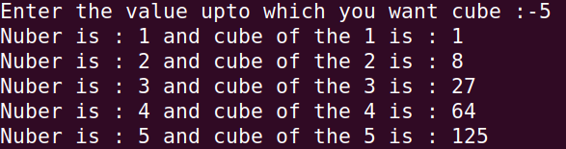

**6. Shell Script to display the multiplication table for a given integer.**

**Test Data :**

**Input the number (Table to be calculated) : 15**

**Expected Output :**

**15 X 1 = 15**

**...**

**...**

**15 X 10 = 150**

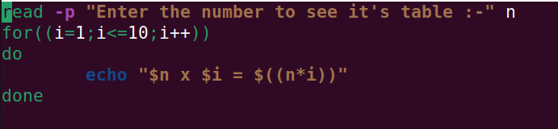

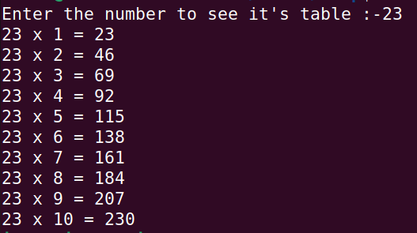

**7. Shell Script to display the multiplier table vertically from 1 to n.**

**Test Data :**

**Input upto the table number starting from 1 : 8**

**Expected Output :**

**Multiplication table from 1 to 8**

**1x1 = 1, 2x1 = 2, 3x1 = 3, 4x1 = 4, 5x1 = 5, 6x1 = 6, 7x1 = 7, 8x1 = 8**

**...**

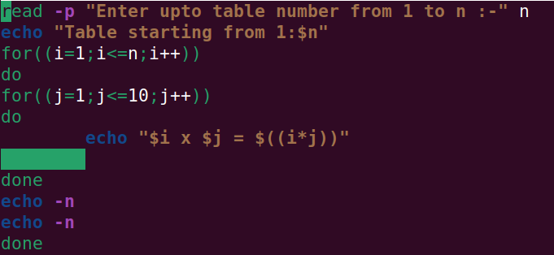**1x10 = 10, 2x10 = 20, 3x10 = 30, 4x10 = 40, 5x10 = 50, 6x10 = 60, 7x10 = 70, 8x10 = 80**

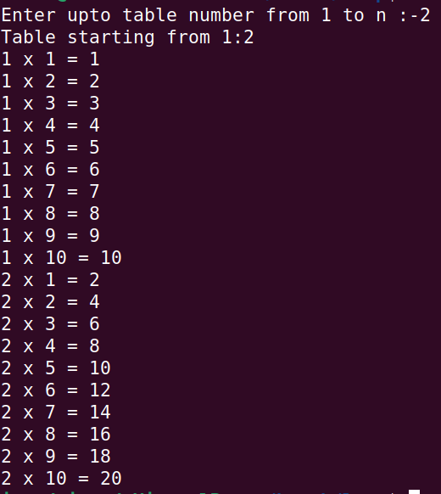

**8. Shell Script to display the n terms of odd natural numbers and their sum.**

**Test Data**

**Input number of terms : 10**

**Expected Output :**

**The odd numbers are :1 3 5 7 9 11 13 15 17 19**

**The Sum of odd Natural Number upto 10 terms : 100**

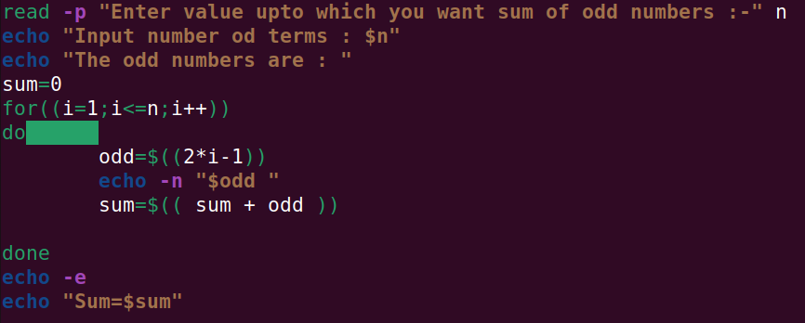

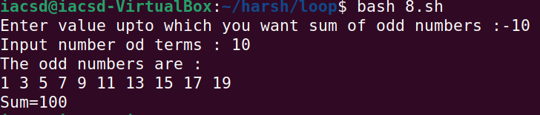

**9. Shell Script to display a pattern like a right angle triangle using an asterisk.**

**The pattern like :**

**\***

**\*\***

**\*\*\***

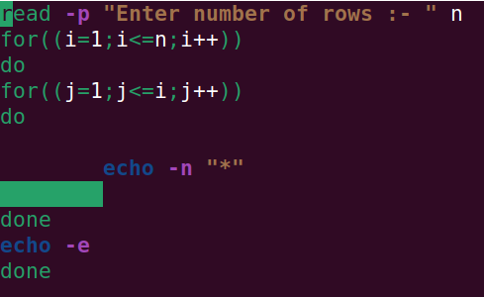**\*\*\*\***

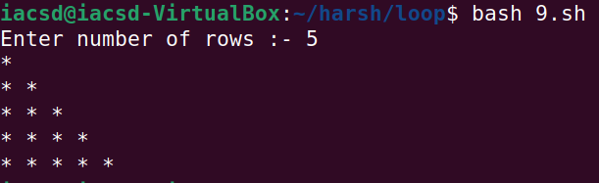

**10. Shell Script to display a pattern like a right angle triangle with a number.**

**The pattern like :**

**1**

**1 2**

**1 2 3**

**1 2 3 4**

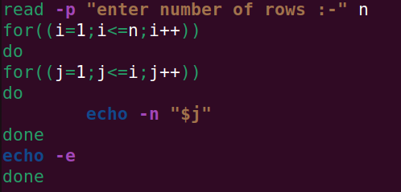

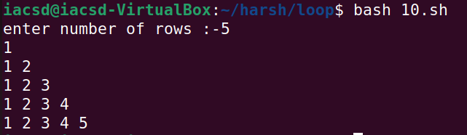

**11. Shell Script to make such a pattern like a right angle triangle with a number which will repeat a number in a row.**

**The pattern like :**

**1**

**2 2**

**3 3 3**

**4 4 4 4**

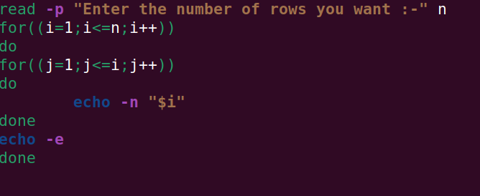

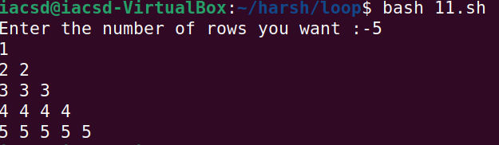

**12. Shell Script to make such a pattern like a right angle triangle with the number increased by 1.**

**The pattern like :**

**1**

**2 3**

**4 5 6**

**7 8 9 10**

